Source of bounty:

Source code:
https://github.com/firedancer-io/firedancer/releases?utm_source=immunefi

Finding：
Remote genesis TAR size integer overflow can cause out-of-bounds read and bootstrap crash

Location：
- src/discof/genesis/fd_genesi_tile.c:276: reads blob_sz from the TAR header
- src/discof/genesis/fd_genesi_tile.c:277: evaluates 512UL + blob_sz without overflow protection
- src/discof/genesis/fd_genesi_tile.c:280: subsequently uses the attacker-controlled blob_sz in hashing logic
- src/util/archive/fd_tar.h:84: binary TAR size path returns an unchecked ulong
- src/util/archive/fd_tar.h:90: octal TAR size parsing does not validate characters or overflow
Description / Impact：
A malicious genesis peer can craft a genesis.tar.bz2 archive whose TAR size field is set to ULONG_MAX or another extremely large value. In that case, the expression 512UL + blob_sz may wrap around due to unsigned integer overflow. As a result, the length check may incorrectly succeed even though the claimed payload size exceeds the available decompressed buffer. The same oversized blob_sz is then passed to fd_sha256_hash(blob, blob_sz) and later consumed by the genesis parser, which may cause reads beyond the end of the decompressed buffer. The most conservative impact is a validator crash or denial of service during the bootstrap phase.

PoC Explanation(Minimal_overflow_test.c)：

To validate the arithmetic core of the issue without relying on the full Firedancer runtime, I created a minimal standalone C proof-of-concept. The test reproduces the same boundary-check pattern used by the target code:

actual_decompressed_sz >= 512UL + tar_sizeThe PoC sets actual_decompressed_sz = 512 and tar_size = ULONG_MAX, then evaluates the expression under normal C unsigned integer semantics. Instead of producing a very large value, 512UL + tar_size wraps around and becomes 511. As a result, the comparison becomes: 512 >= 511 and incorrectly evaluates to true. This demonstrates that the validation pattern is unsafe, because an extreme attacker-controlled size can cause the bounds check to succeed when it should logically fail.

The PoC does not attempt to reproduce the entire Firedancer bootstrap path, nor does it by itself prove full exploitability in the complete runtime. Its purpose is narrower and more precise: it confirms that the critical arithmetic assumption behind the check is invalid under extreme input conditions. Combined with source-code analysis showing that the same unchecked size is later passed into hashing and parsing operations, this provides meaningful support for the conclusion that the original code path is vulnerable to bootstrap-stage denial of service and carries potential out-of-bounds read risk.
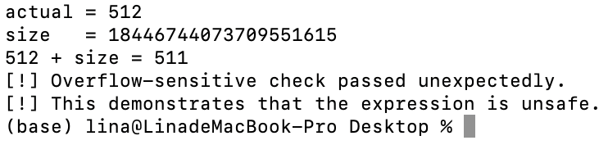
Why I Consider This a Zero-Day ：

I consider this issue a zero-day candidate because, based on the public information I reviewed, I did not find a clearly matching prior public report describing this specific vulnerability chain. In particular, I checked Firedancer’s public security guidance in https://github.com/firedancer-io/firedancer/blob/main/SECURITY.md and the public known-issues umbrella in issue https://github.com/firedancer-io/firedancer/issues/9228 . I also reviewed the most relevant public component issue trackers, including restore known issues https://github.com/firedancer-io/firedancer/issues/9176 and util known issues https://github.com/firedancer-io/firedancer/issues/9177 . I did not identify a public entry that explicitly covers the remote genesis.tar.bz2 TAR size parsing path, the unchecked 512UL + blob_sz arithmetic, and the resulting risk of bounds-check bypass followed by out-of-bounds read during bootstrap.

My classification is intentionally cautious. I am not claiming with certainty that the issue has never been reported before, because there may be private disclosures, internal reports, or unpublished audit findings that are not visible to me. But before I upload it to the company, I would like to ask you to help me determine whether this is an existing vulnerability and whether it can be regarded as zero day.

